Project Plan

Pronounciation Trainer

Lokesh Agnihotri

#### Version history

|  |  |  |  |  |
| --- | --- | --- | --- | --- |
| **Version** | **Date** | **Author(s)** | **Changes** | **State** |
| 1.0 | 6/12/2023 | Lokesh Agnihotri | Initial Draft | Draft |
|  |  |  |  |  |
|  |  |  |  |  |

**Distribution**

|  |  |  |
| --- | --- | --- |
| **Version** | **Date** | **Receivers** |
| 1.0 | 6/13/2023 | Ruissen,Martijn,  Janssen,Olaf,  Saçan,Erdinç.,  Huijts,Ruud. |
|  |  |  |

Contents

1. Project assignment 4

1.1 Context 4

1.2 Goal of the project 4

1.3 Scope and preconditions 4

1.4 Strategy 4

1.5 Research questions 4

1.6 End products 4

2. Project Organisation 6

2.1 Stakeholders and team members 6

2.2 Communication 6

3. Activities and time plan 7

3.1 Phases of the project 7

3.2 Time plan and milestones 7

4. Testing strategy and configuration management 8

4.1 Testing strategy 8

4.2 Test environment and required resources 8

4.3 Configuration management 8

5. Finances and Risk 9

5.1 Project budget 9

5.2 Risk and mitigation 9

# Project assignment

## Context

Practoraat Interactieve Technologie van ROC Tilburg, wants to create a web based Pronounciation

Trainer for MBO 2,3 and 4 students, in order to help them with their English prounouncation.

## Goal of the project

## The goal of this project is to develop a web-based application that provides feedback to users on their English pronunciation skills. The primary reason for undertaking this project is to assist students in levels MBo2, MBo3, and MBo4 who come from diverse backgrounds and speak different languages, enabling them to improve their spoken English with accurate pronunciation.The preferred situation is to deliver a user-friendly and interactive application that clients can utilize to help their students practice English pronunciation. The project offers several advantages:

## Accessibility: Students can access the application at any time, eliminating the need for a personal trainer to be present continuously. They can practice the same sentences repeatedly to enhance their pronunciation of specific words.

## Flexibility: The tool can be used both online and offline, providing flexibility for students in various learning environments.

## Engaging Learning Experience: The application will provide a seamless and intuitive user interface, making it easy for students to practice their pronunciation

## Enhanced Learning Speed: The tool enables the organization to accelerate students' pronunciation improvement by offering a dynamic and less traditional study approach. It provides a platform for students to practice pronunciation effectively, leading to faster progress in their language skills.

## By addressing the need for improved pronunciation in an engaging and accessible manner, this project adds value to the company's context by providing an innovative solution for language learning. It equips students with the necessary tools to develop their pronunciation skills, contributing to their overall language proficiency and communication abilities.

## Scope and preconditions

The scope of this project includes the development and implementation of a web-based application that focuses on providing feedback on English pronunciation skills. It encompasses the following key components:

* **User Interface**: Designing an intuitive and user-friendly interface that allows users to input sentences and receive feedback on their pronunciation.
* **Speech Recognition**: Implementing a speech recognition system that can analyze and evaluate user pronunciation based on predefined criteria.
* **Feedback Generation**: Developing algorithms and rules to generate feedback and suggestions for improvement based on the analysis of user pronunciation.
* **Performance** **Optimization**: Ensuring the application performs efficiently and provides real-time feedback to users.
* **Testing and Quality Assurance**: Conducting rigorous testing to ensure the application functions as intended, with high accuracy and reliability.

## Pre-Conditions

To successfully undertake and complete this project, the following pre-conditions need to be considered:

* **Technical Expertise**: The project requires expertise in web development, speech recognition technologies and software testing.
* **Access to Speech Recognition Resources**: Access to speech recognition APIs or libraries that can accurately analyze and evaluate user pronunciation is necessary.
* **User Engagement**: User participation and willingness to utilize the application for practicing pronunciation are crucial for the success of the project.
* **Hardware and Software Requirements**: The project assumes that users have access to devices (computers, smartphones, etc.) with microphones and internet connectivity to use the application.

## Out of Scope

The following aspects are considered outside the scope of this project:

* **Advanced Speech Analysis:** In-depth analysis of prosody, intonation, and other advanced speech features beyond basic pronunciation evaluation.
* **Language Learning Content**: The project does not involve the creation or provision of language learning content, such as lessons, exercises, or vocabulary.
* **Gamification Elements**: While the application aims to provide an engaging experience, the inclusion of extensive gamification features or game-like progression systems is beyond the scope.
* **Individualized Pronunciation Plans**: Developing personalized pronunciation improvement plans or tailored recommendations for individual users is not included.
* **Cross-Language Pronunciation Evaluation**: Evaluating pronunciation accuracy and providing feedback across multiple languages beyond English is not within the project scope.
* **Translation Services**: Translation of sentences or words from one language to another is not part of this project.

## Strategy

Adopting a 3-day sprint basis for software development can help strike a balance between productivity and adaptability. This approach aligns with iterative development and frequent feedback, allowing for timely adjustments as per Agile principles.

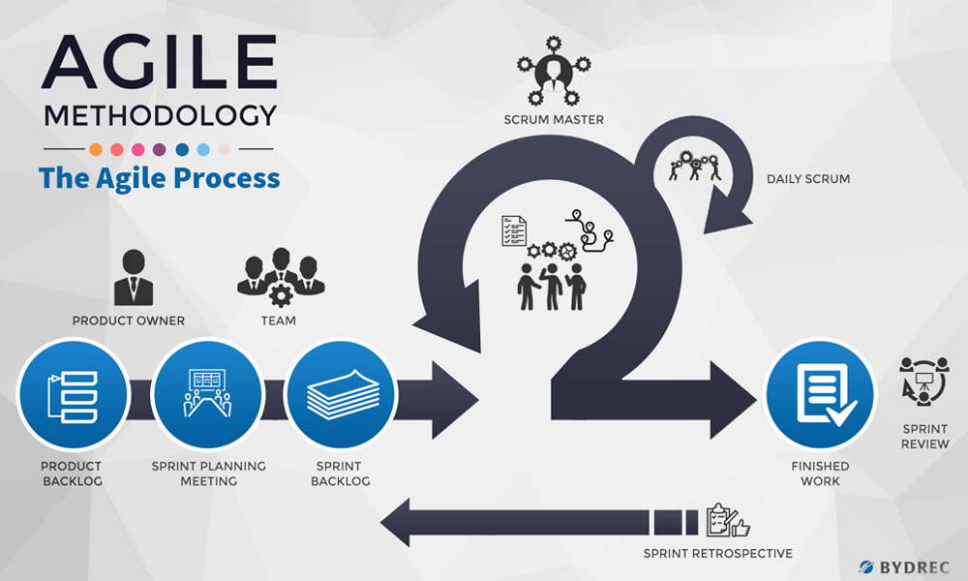

In each sprint, a comprehensive testing process should be included to maintain software quality. Two important types of tests to incorporate are unit tests and user tests. Unit tests verify the functionality of individual code components, ensuring a stable and error-free codebase. User tests involve gathering feedback from actual users to gain insights into usability and user experience, enabling informed decision-making and improvements based on user needs. To ensure software quality, principles of Continuous Integration and Continuous Deployment (CI/CD) can be applied, with automated testing at every commit. User tests will be conducted at specific intervals to balance value and time.

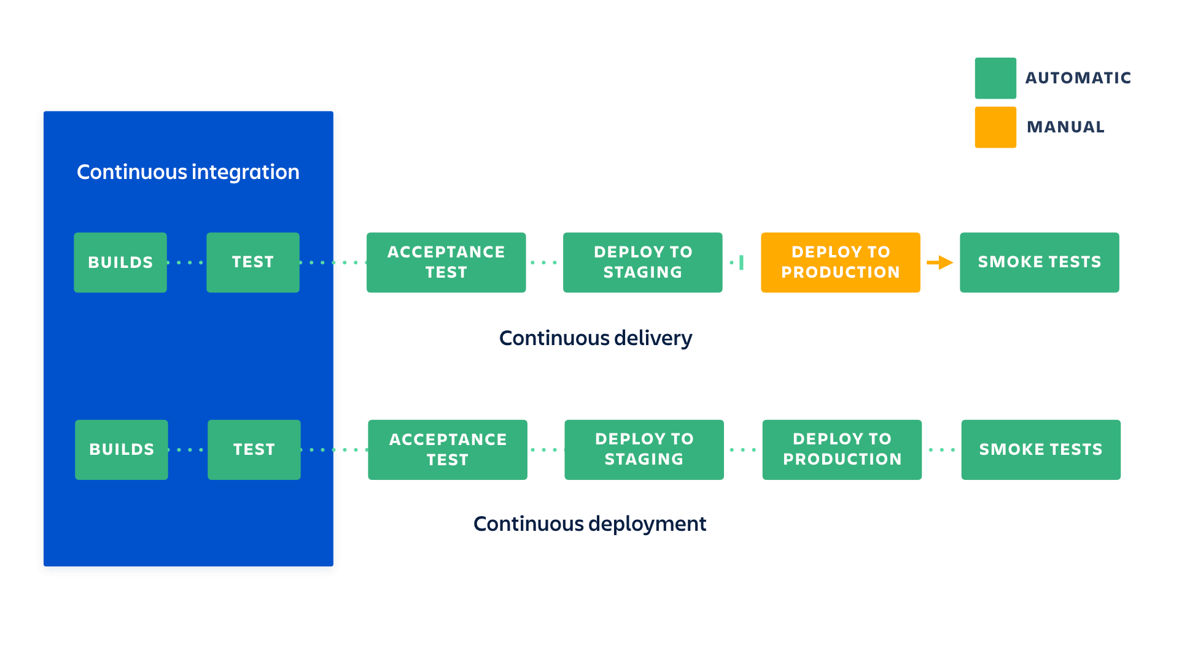

## Research questions

* What the available methodologies and techniques used in pronounciation training apps?
* What are the best available applications for pronounciation training?
* Is it already done?
* How should the components of my app, connect to each other?
* development process and enhance the effectiveness of my app.
* System Test
* Unit Test
* Which project management tool shall I use?

## End products



# Project organisation

## Stakeholders and team members

|  |  |  |
| --- | --- | --- |
| **Name** | **Role and functions** | **Availability** |
| Saçan,Erdinç | Stakeholder | Once or twice a week as per availability, flexible. |
| Janssen,Olaf | Coach | Flexibile availability when help is needed. |
| Huijts,Ruud | Coach | Have to discuss available time. |
| Ruissen,Martijn | Co-ordinator | Available on teams or email and in person. Flexible schedule. |

## Communication

Communication with teachers, coaches, and stakeholders is conducted in a professional and flexible manner. Meetings will be scheduled to facilitate discussions, and additional communication channels such as Teams chat and emails are utilized for ongoing collaboration.

On Tuesdays, in-person meetings can be arranged with teachers, coaches, and stakeholders who are available at the building. This provides an opportunity for weekly updates to be delivered in person, fostering effective communication and ensuring everyone is well-informed about the progress of the project.

## Activities and time plan

## Phases of the project

**1. Initiation Phase:**

- Problem Analysis: Identify and define the problem or opportunity that the project aims to addre

- Stakeholder Identification: Identify and engage key stakeholders who will be involved or impacted by the project.

2**. Planning Phase:**

- Requirements Gathering: Gather and document the specific requirements and objectives of the project.

- Project Planning: Develop a detailed project plan, including tasks, timelines, resource allocation, and milestones.

- Risk Assessment: Identify and analyze potential risks and develop strategies to mitigate them.

**3. Execution Phase:**

- Development: Implement the project plan by executing the tasks and activities defined in the project plan.

- Monitoring and Control: Regularly monitor project progress, track key metrics, and ensure adherence to the project plan.

- Communication and Collaboration: Maintain effective communication channels among stakeholders and coaches.

- Quality Assurance: Conduct testing and quality checks to ensure that project deliverables meet the required standards.

**4. Evaluation Phase:**

- Testing and Validation: Conduct comprehensive testing of the project deliverables to ensure functionality, usability, and reliability.

- User Acceptance Testing: Engage stakeholders and end users to validate the project's outcomes and gather feedback.

- Evaluation and Review: Assess the project's performance against the defined objectives and make any necessary adjustments or improvements.

- Documentation: Document the project outcomes, lessons learned, and best practices for future reference.

**5. Closure Phase:**

- Handover: Transfer project deliverables, knowledge, and documentation to the stakeholder.

- Reflection and Lessons Learned: Conduct a post-project review to identify strengths, weaknesses, and areas for improvement.

- Project Wrap-up: Complete any remaining administrative tasks, close contracts, and archive project-related documents.

## Time plan and milestones

I will be adopting the 3-day sprint methodology for the project implementation. At the conclusion of each sprint, I will allocate dedicated time for a one-hour retrospective session. This retrospective will serve as an opportunity to reflect on the sprint, identify areas for improvement, and implement necessary adjustments to enhance project outcomes. By regularly engaging in retrospection, I aim to foster continuous improvement and optimize the overall project execution

|  |  |  |  |
| --- | --- | --- | --- |
| **Phasing** | **Effort** | **Start date** | **Finish date** |
| 1. Sprint 1 | Requirement analysis, Acceptance Criteria | 5/6/2023 | 8/6/2023 |
| 1. Sprint 2 | Best technlogy for front end, Back end and AI logic | 9/6/2023 | 13/6/2023 |
| 1. Sprint 3 | Project plan, Design, Implementation start | 14/6/2023 | 19/6/2023 |
| 1. Sprint 4 | Make the product | 20/6/2023 | 30/6/2023 |
| 1. Sprint 5 | Fix bug and handover | 1/7/2023 | 7/7/2023 |

# Testing strategy and configuration management

## 

## Testing strategy

For my testing strategy, I will be focusing on unit testing and system testing, along with the implementation of continuous integration and continuous deployment (CI/CD) practices.

**Unit Testing**:

Unit testing will involve testing individual components or units of code to ensure their functionality and correctness. It helps identify and resolve bugs, errors, and unexpected behaviors at an early stage of development. I will create unit tests using testing frameworks like JUnit or Pytest to automate the testing process and ensure consistent and reliable results.

**System Testing:**

System testing will evaluate the behavior and performance of the entire system as a whole. It will involve testing the integrated components and their interactions to ensure the system functions correctly and meets the specified requirements. I will conduct both manual and automated system tests to validate the system's functionality, reliability, and performance in real-world scenarios.

**CI/CD:**

To streamline the development process and ensure continuous integration and deployment, I will adopt CI/CD practices. This involves automating the build, test, and deployment processes to enable frequent and reliable software releases. With CI/CD, each code commit triggers automated testing, including unit tests and system tests, to validate the code changes and maintain the stability of the software.

By implementing a comprehensive testing strategy that includes unit testing, system testing, and the integration of CI/CD practices, I will ensure the reliability and quality of the pronunciation trainer app throughout its development lifecycle.

## Configuration management

I will implement a simplified version management approach and provide mechanisms to handle change requests and problem reports effectively.

**Version Management Approach:**

For version management, I will utilize Git as the version control system, leveraging its local repository capabilities. This will allow me to track changes, maintain a history of revisions, and revert to previous versions if necessary.

**Change Requests and Problem Reports Mechanism:**

To manage change requests and problem reports without a ticketing system, I will adopt the following approach:

Prioritize tasks based on their impact and urgency, addressing critical issues first.

Perform thorough testing and verification of changes before integrating them into the main codebase.

Keep clear documentation of implemented changes and resolutions, including any relevant notes or instructions.

By implementing this simplified version management approach and a manual mechanism for change requests and problem reports, I aim to develop a functional English Pronunciation Trainer app that helps English learners improve their pronunciation skills efficiently.

# Finances and risk

## Project budget

There will be no financial assistance required to successfully complete this project as all the technologies utilized will be free and open source. This decision is in alignment with the stakeholder's preference for a cost-effective solution. By selecting open source technologies, I aim to minimize expenses while delivering a high-quality outcome.

## Risk and mitigation

* **Risk**: **Technical Compatibility Issues**

**Prevention**: Thoroughly evaluate the compatibility of different technologies and components before integrating them into the project. Conduct extensive research and perform compatibility tests to identify any potential issues early on. Ensure that all technologies and components are compatible with each other and with the project requirements.

**Mitigation**: Establish a contingency plan to address compatibility issues if they arise during the project. This may involve seeking alternative technologies or finding workarounds to ensure smooth integration. Maintain open communication channels with relevant stakeholders to address any technical compatibility concerns promptly.

* **Risk: Scope Creep**

**Prevention**: Clearly define and document the project scope, including the deliverables, timelines, and objectives. Engage stakeholders early on to ensure a shared understanding of the project's boundaries and objectives.

**Mitigation**: Regularly review and reassess project scope throughout the development process. Any proposed changes should undergo a formal evaluation process to assess their impact on timelines, resources, and project objectives. Prioritize changes based on their alignment with project goals and available resources.